GRADE: V MONTHLY TEST (SEPTEMER) 2019 – 20 MARKS: 60
DATE: 20.09.2019 SCIENCE TIME:3Hrs

I. Choose the correct answer: (5X1=5)
1. Which of these joints allows movement in one direction only?
a) hinge joint b) ball and socket joint c) pivot joint
2. Which of the following is a kharif crop?
a) wheat b) gram c) rice
3. This is not a bird.
a) bat b) crow c) pigeon
4. The molecules in solids are
a) loosely packed b) tightly packed c) fast moving
5. The process of change of a liquid into its solid state on cooling is called
a) freeing b) melting c) evaporation

II. Name the following: (5x1=5)
6. The smallest bone in our body.
7. The baby plant inside the seed.
8. Underground stem of onion plant.
9. Non-flowering plants that bear scaly cone-shaped structures.
10. Plants that have seeds with two seed leaves.

III. Picture based questions: (5)
- a)Identify the bone and joint: (1 ½)
- ii) iii)
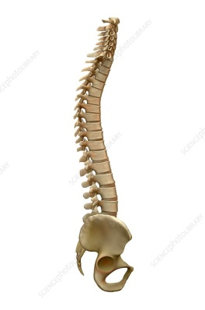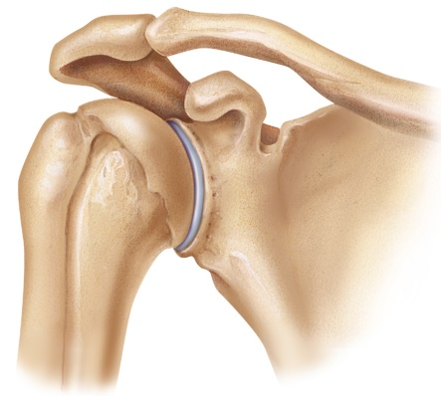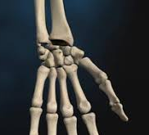

- Identify the activities as physical (P) or chemical (C) changes:(1 ½)
- ii) iii)
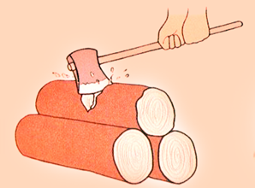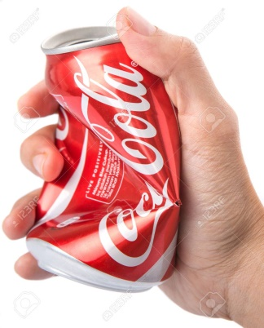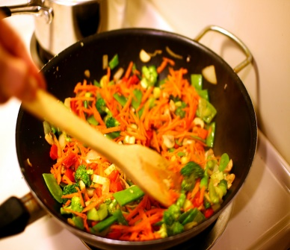

- Complete the flowchart: (2)

Types of Animals

 |  | Birds |  | Reptiles

Fish

IV. Very Short answer type questions: (5x2=10)
12.Name the types of joints in our body and give one example of each.
13. What is the difference between a sensory nerve and a motor nerve?
14. List the conditions necessary for germination.
15. Write the differences between turtles and tortoises.
16. Differentiate between melting and freezing.

V. Short answer type questions: (5x3=15)
17. What are the functions of the skeleton?
18. Describe the structure of a seed coat.
19. Why do plants have to disperse their seeds? What features of the coconut and lotus fruits allow them to get disperse by water?

20. Name the different families of non-flowering plants. Write two features for any one of them.
21. Why do solids change into liquids on heating?

VI. Answer in detail: (4x5=20)
22. Explain the working of muscles.
- What are crops? List the different factors a farmer should keep in mind to get a good harvest.
- Write three features each of a fish and an amphibians.
- a)Explain why liquids are able to flow while solids are not.
b)Why does sugar dissolve faster in hot water than in cold water?

